1. **Product with highest sale**

SELECT

[Product Category],

SUM([Sales]) AS Total_Sales

FROM

KMS_Orders

GROUP BY

[Product Category]

ORDER BY

Total_Sales DESC;

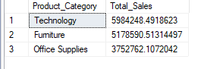

1. **What are the Top 3 and Bottom 3 regions in terms of sales?**

SELECT

[Region],

SUM([Sales]) AS Total_Sales

FROM

[dbo].[KMS Sql Case Study]

GROUP BY

[Region]

ORDER BY

Total_Sales DESC

OFFSET 0 ROWS FETCH NEXT 3 ROWS ONLY;

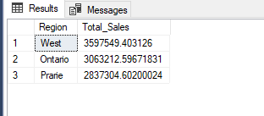

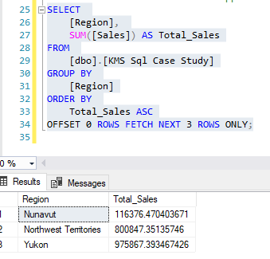

1. **What were the total sales of appliances in Ontario?**

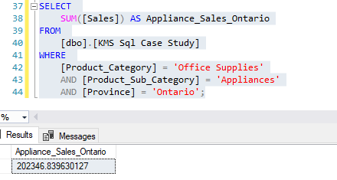

1. **Advise the management of KMS on what to do to increase the revenue from the bottom 10 customers**

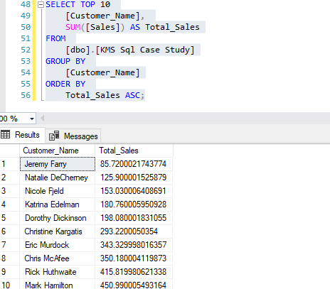

1. **KMS incurred the most shipping cost using which shipping method?**

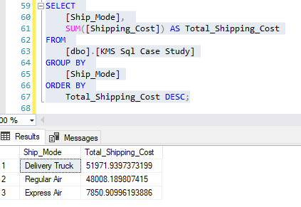

1. **Who are the most valuable customers, and what products or services do they typically purchase?**

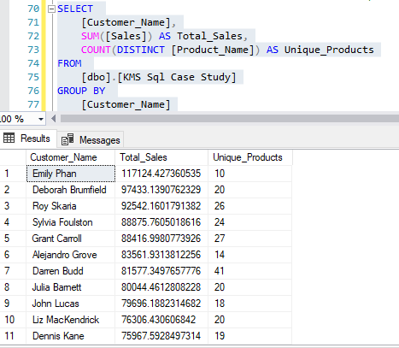

1. **Which small business customer had the highest sales?**

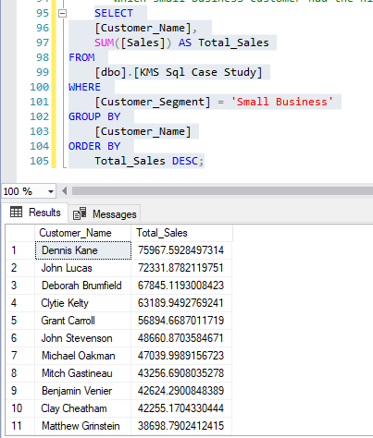

1. **Which Corporate Customer placed the most number of orders in 2009 – 2012?**

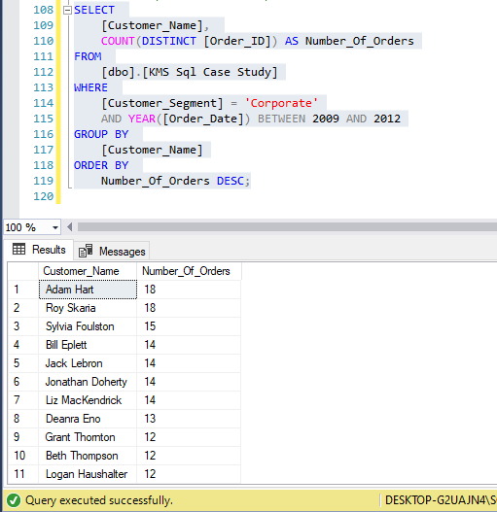

1. **Which consumer customer was the most profitable one?**

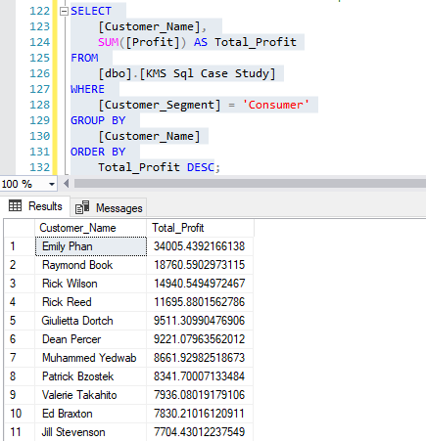

1. **Which customer returned items, and what segment do they belong to?**

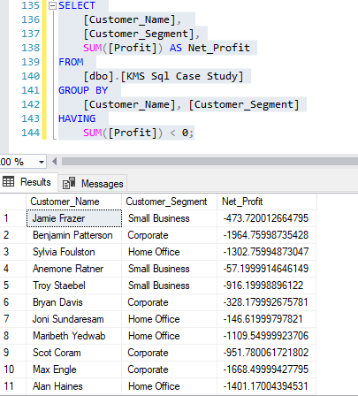

1. **If the delivery truck is the most economical but the slowest shipping method and Express Air is the fastest but the most expensive one, do you think the company appropriately spent shipping costs based on the Order Priority? Explain your answer**

